Xmas Mode 'On': stay with us throughout December.

About Synonyme.net
Genius ConfCall:
Simultaneous interpreting via teleconference or streaming in various languages, without leaving your desk, with each interlocutor speaking their own language
Translation, transcription, dubbing and subtitling:
A service based on reactivity (quote in 1 hour, 4,000 words per day, per language), quality (complying with the ISO 9001:2008 & UNE EN 15038 norms, review by experts) and consistency between all languages
Content generation:
Ensure adequate SEO/SEM positioning in various languages by publishing your multilingual message on your website.
Event Organisation:
Throughout Europe at local prices
Tool creation and localisation::
E-learning platforms and internal communication in different languages with total security and confidentiality
Last but not least, bear in mind that we are based in Madrid, and therefore don’t apply VAT to clients situated outside Spain.

Current developments in machine translation
We are following progress in this area and keeping our clients updated. For the time being, although things are moving in the right direction, we are maintaining our double expert quality review process. While the expansion of machine translation can reduce costs, it can also adversely affect the quality of the translation produced. Mistranslations, hidden slips or imprecise interpretations are still too great a risk in banking, finance, law or medical translation. In any case, mistakes can still occur in texts as short and straightforward as this one:

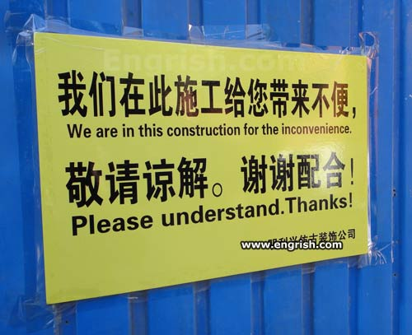
Photo: engrish.com
The definition of quality is what a client is willing to pay for. However, nobody wishes to face risk, particularly the legal risks associated with a poor translation.
One example of how the market is approaching this dilemma:
http://support.microsoft.com/kb/300926/es
http://support.microsoft.com/gp/machine-translation-corrections/es-es

SYNONYME.NET: Our unique combination of sectoral expertise, advanced language technology and excellent customer service is our brand.

The SYNONYME one-stop shop
Why not shorten your procurement chain? Think of us as a one-stop shop that can help you save time and money.
SYNONYME has 25 years of experience in the industry, working with clients throughout Europe. Based in Spain, we are able to offer very attractive prices compared to our competitors in Northern Europe - or even further afield…. In fact, SYNONYME has clients all over the world!
Translations are delivered in the original format and updated in the blink of an eye because repetitions are always taken into account. This way we save you time and valuable resources and shorten the procurement chain as we deal several services at once.

www.geniusconfcall.com
Genius Conference Call: Our innovative interpreting service
Avoid added stress this festive season and ask us about our multilingual Genius ConfCall simultaneous interpreting service. Genius ConfCall.com is perfectly suited to these tough economic times: saving you time and money while not compromising on quality. See our teaser below for more information:
www.geniusconfcall.com

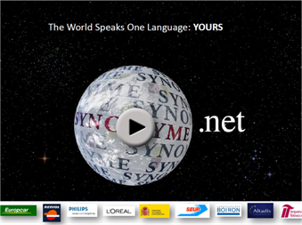

Synonyme Services ESP
Synonyme Services FRA
Synonyme Services ENG

Psst...are you on a business trip to Madrid any time soon? Check out our accommodation partners: www.madridcitybreak.es


Launching your products and services on a global scale goes hand in hand with translation and international communication. We cover a wide range of services, but our focus is always on guaranteeing optimum quality whilst offering a competitive turnaround and price. Our sectoral expertise, advanced language technology and excellent customer service offer you peace of mind.

Contact
synonyme@synonyme.net
Paseo de la Ermita 2, 28023, Madrid - España
Opening hours:
9am - 7pm, weekdays.
Tel:+ 34 913 079 203
Fax:+34 917 400 657

To unsubscribe, click here

