Having trouble reading this email? Click here to see it in your browser


The world speaks one language. Yours.   

Synonyme.net comes to the fore with a new range of integrated solutions
May-June 2014

    International conferencing at your desk  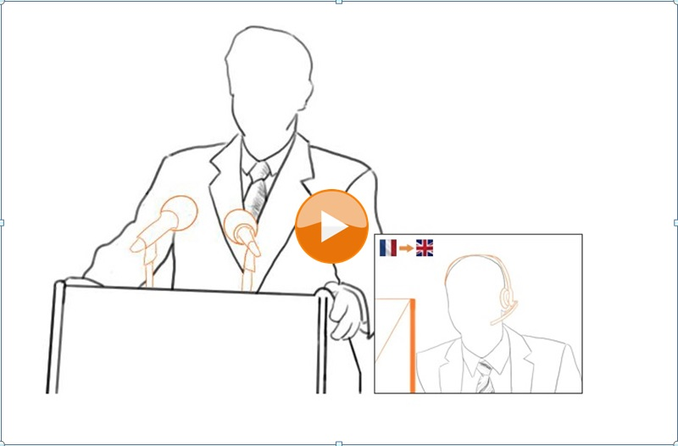  Our conference interpreters are closer than you think.  - International meetings in multiple languages from €1000, at 24 hrs notice  - On the phone or online  - Available 24hrs a day  Advantages: reduce your travel costs, save time and improve quality control, thanks to our integrated global language solutions and our project costs.  Our ongoing competitive oversight on machine translation reveals that Skype translation appears to offer a solution of potential interest that is perhaps limited to the private sphere. In professional situations, however, no one undertakes unnecessary risks, especially considering the legal repercussions of an incorrect translation.  https://www.youtube.com/watch?v=eu9kMIeS0wQ  Would you entrust your teleconference translation to a 4 year-old child who would merely talk about the “colour of their marker” or the “date of an email”. Clearly, the answer is no.  In the professional sphere, much of the content that is more subtle and complex in nature poses true challenges in translation.  The added value of Synonyme.net lies in a unique combination of first-hand knowledge of the subject matter, avant-garde linguistic technology and our optimised customer service.  Publishing problems?    Integrated solutions from a wide range of communication and publishing professionals.  Responding to your business needs:  - Audio, video, document and web formatting and mastering  - Ready-to-publish translations, in any language.  - Audio-visual dubbing and subtitling  Listen to examples of multi-lingual e-learning voiceovers  Benefits:  - Reduce costs  - Save time  - Quality control, from native linguists  in partnership with   Synonyme.net in partnership with My Oxford English.  - Flexible online English tuition, delivered by the experts  - Perfect your conversational and specialist English  - Tailored to your needs: accounting, finance, business, science, human resources, medicine  - Intensive, high-quality, personalised teaching  - Tutor support to help you reach your goals  - Qualifications endorsed by Oxford University  - View demo!  Fees:  - Level 1, 6 month course, with online personal tutor: 240 euro VAT not applicable  - Level 1, 6 month e-learning: 150 euro VAT not applicable  About Synonyme.net:  At Synonyme.net we stay true to our values: competitive pricing, quality, fast turnarounds and an excellent customer service. Our solutions support more than 1000 clients since the creation of the company, who trust us with their communications needs, their senior management reports and their work force.  Customer satisfaction is guaranteed when the service provided exceeds their expectations.
  About Synonyme.net
  Genius ConfCall or interconnectivity version 2014:
  Simultaneous interpreting via teleconference or streaming in various languages, without leaving your desk, with each interlocutor speaking their own language.
  http://www.geniusconfcall.com/en/
  Translation, transcription, dubbing and subtitling:
  A service based on reactivity (quote in 1 hour, 4,000 words per day, per language), quality (complying with the ISO 9001:2008 & UNE EN 15038 norms, review by experts) and consistency between all languages.
  Content generation:
  Ensure adequate SEO/SEM positioning in various languages by publishing your multilingual message on your website.
  Event Organitzation:
  Throughout Europe at local prices.
  Tool creation and localisation:
  E-learning platforms and internal communication in different languages with total security and confidentiality.
  Last but not least, keep in mind that we are based in Madrid, and therefore don’t apply VAT to clients situated outside of Spain.
  Contact
  Paseo de la Ermita 2, 28023, Madrid - España
  Horario:
  9am - 7pm, L-V
  Tlf:+ 34 91307 92 03
  F:+34 91740 06 57
  Web : http://synonyme.net/
  Mail: synonyme@synonyme.net
  Twitter: https://twitter.com/SynonymeNet
  Facebook: https://www.facebook.com/synonyme.net
%%unsubscribelink%%">To unsubscribe, click here

